Lesson 06 Demo 02

Creating a Virtual Machine Backup

Objective: To backup virtual machine from VM settings
Tools Required: None

Prerequisites: Virtual machine and recovery service vault

Steps to be followed:
- Enable backup on the virtual machine

Step 1: Enable backup on the virtual machine

- Sign in to the Azure portal, select the virtual machine that requires a backup, and click on Backup

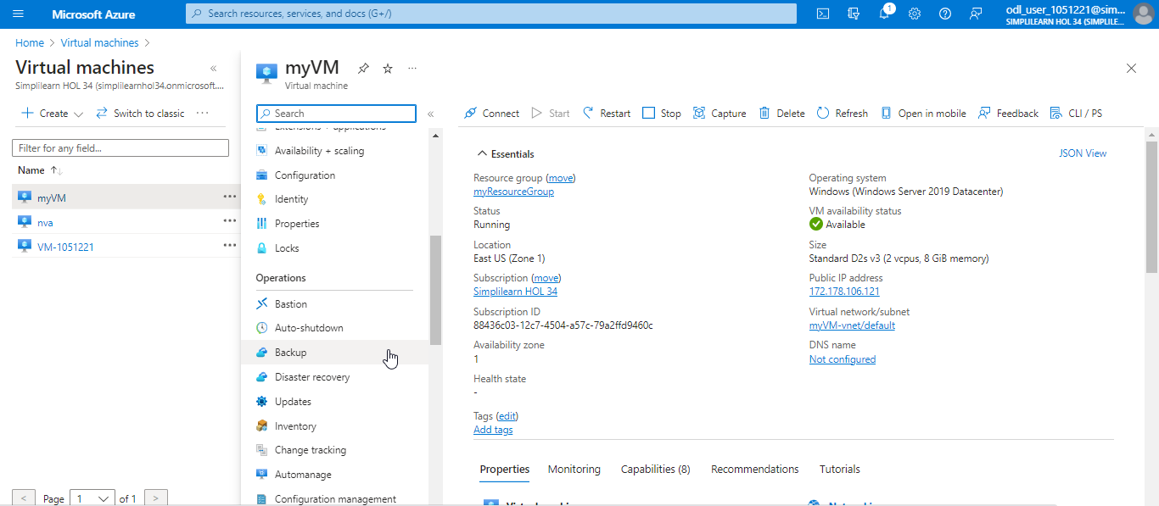

- On the Backup page, navigate to the Recovery Services vault and select Create new. Select Backup vault and Policy sub type based on the user preferences or the options available and click on Enable backup.

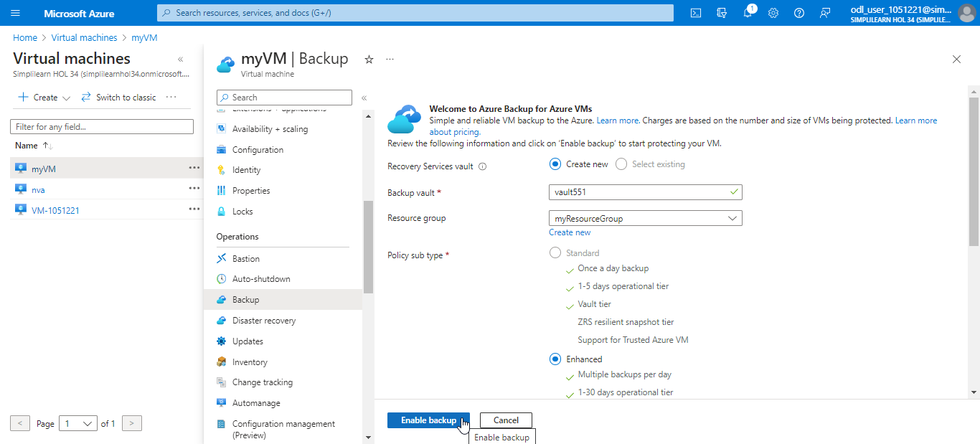

The backup is enabled successfully as shown in the screenshot below:

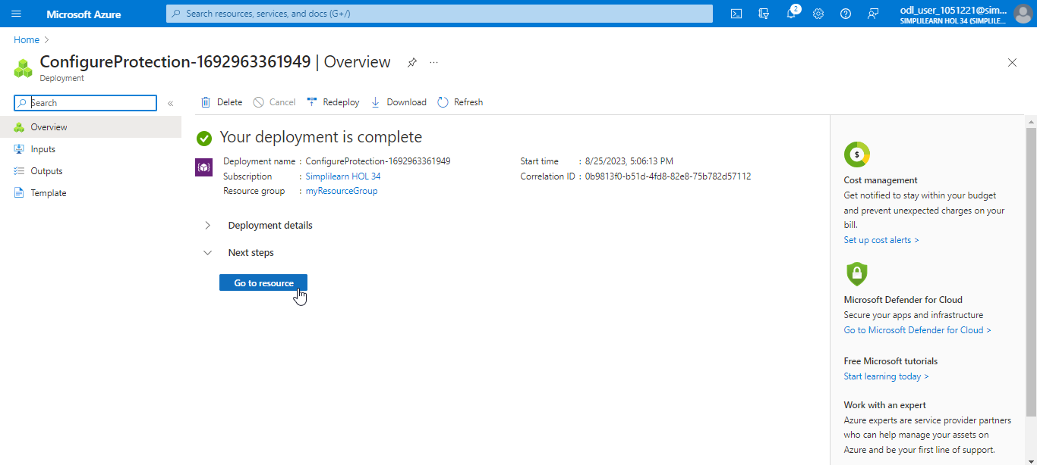

You have successfully taken the backup of the virtual machine to restore environments when needed.

